**Nama :Satriyo Yudha**

**Kelas :T3I**

**NIM :233140707111082**

**MODUL 7**

**7.4 Latihan**

**1. Coba buat aplikasi dengan tiga halaman: Home, About, dan Contact. Gunakan navigasi sederhana dengan Navigator.push dan Navigator.pop untuk berpindah antar halaman.**

import 'package:flutter/material.dart';

void main() {

  runApp(MyApp());

}

class MyApp extends StatelessWidget {

  @override

  Widget build(BuildContext context) {

    return MaterialApp(

      home: HomePage(),

    );

  }

}

class HomePage extends StatelessWidget {

  @override

  Widget build(BuildContext context) {

    return Scaffold(

      appBar: AppBar(

        title: Text('Home Page'),

      ),

      body: Center(

        child: Column(

          mainAxisAlignment: MainAxisAlignment.center,

          children: [

            ElevatedButton(

              onPressed: () {

                Navigator.push(

                  context,

                  MaterialPageRoute(builder: (context) => AboutPage()),

                );

              },

              child: Text('Go to About Page'),

            ),

            ElevatedButton(

              onPressed: () {

                Navigator.push(

                  context,

                  MaterialPageRoute(builder: (context) => ContactPage()),

                );

              },

              child: Text('Go to Contact Page'),

            ),

          ],

        ),

      ),

    );

  }

}

class AboutPage extends StatelessWidget {

  @override

  Widget build(BuildContext context) {

    return Scaffold(

      appBar: AppBar(

        title: Text('About Page'),

      ),

      body: Center(

        child: ElevatedButton(

          onPressed: () {

            Navigator.pop(context);

          },

          child: Text('Back to Home Page'),

        ),

      ),

    );

  }

}

class ContactPage extends StatelessWidget {

  @override

  Widget build(BuildContext context) {

    return Scaffold(

      appBar: AppBar(

        title: Text('Contact Page'),

      ),

      body: Center(

        child: ElevatedButton(

          onPressed: () {

            Navigator.pop(context);

          },

          child: Text('Back to Home Page'),

        ),

      ),

    );

  }

}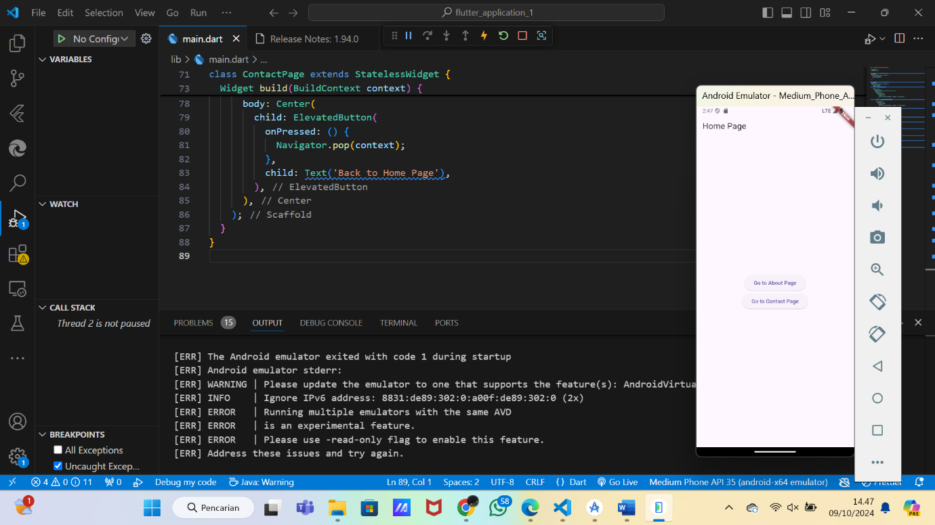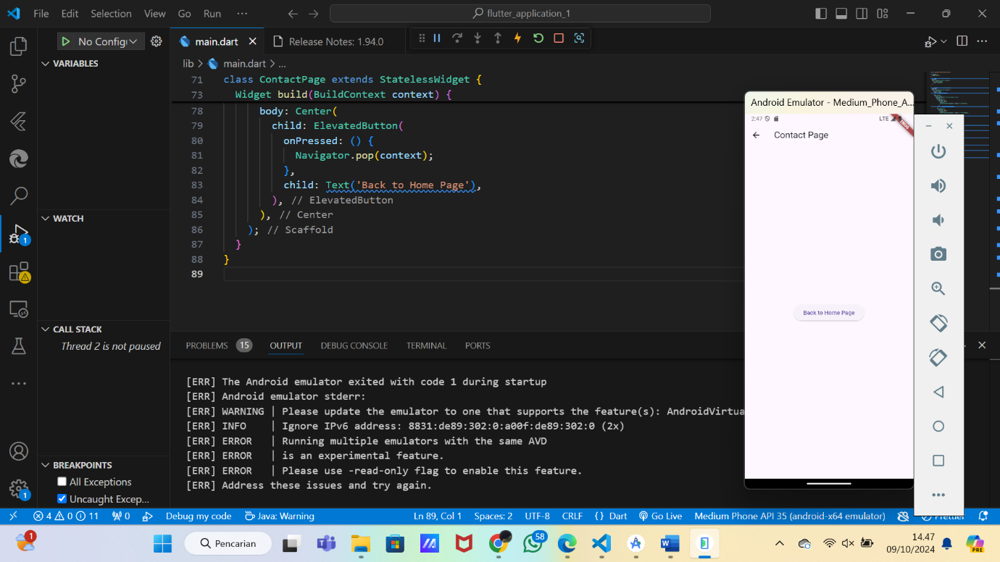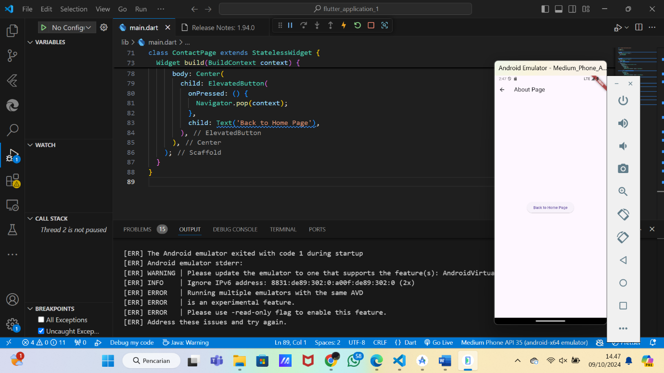

**2. Implementasikan named routes untuk navigasi antara halaman dan kirimkan data antar halaman menggunakan arguments. Misalnya, kirimkan pesan selamat datang dari halaman Home ke halaman About.**

import 'package:flutter/material.dart';

void main() {

  runApp(MaterialApp(

    initialRoute: '/',

    routes: {

      '/': (context) => HomePage(),

      '/about': (context) => AboutPage(),

      '/contact': (context) => ContactPage(),

    },

  ));

}

class HomePage extends StatelessWidget {

  @override

  Widget build(BuildContext context) {

    return Scaffold(

      appBar: AppBar(

        title: Text('Home Page'),

      ),

      body: Center(

        child: Column(

          mainAxisAlignment: MainAxisAlignment.center,

          children: [

            ElevatedButton(

              onPressed: () {

                Navigator.pushNamed(

                  context,

                  '/about',

                  arguments: 'Welcome to the About Page!',

                );

              },

              child: Text('Go to About Page'),

            ),

            ElevatedButton(

              onPressed: () {

                Navigator.pushNamed(context, '/contact');

              },

              child: Text('Go to Contact Page'),

            ),

          ],

        ),

      ),

    );

  }

}

class AboutPage extends StatelessWidget {

  @override

  Widget build(BuildContext context) {

    final String message = ModalRoute.of(context)!.settings.arguments as String;

    return Scaffold(

      appBar: AppBar(

        title: Text('About Page'),

      ),

      body: Center(

        child: Column(

          mainAxisAlignment: MainAxisAlignment.center,

          children: [

            Text(message),

            ElevatedButton(

              onPressed: () {

                Navigator.pop(context);

              },

              child: Text('Back to Home Page'),

            ),

          ],

        ),

      ),

    );

  }

}

class ContactPage extends StatelessWidget {

  @override

  Widget build(BuildContext context) {

    return Scaffold(

      appBar: AppBar(

        title: Text('Contact Page'),

      ),

      body: Center(

        child: ElevatedButton(

          onPressed: () {

            Navigator.pop(context);

          },

          child: Text('Back to Home Page'),

        ),

      ),

    );

  }

}

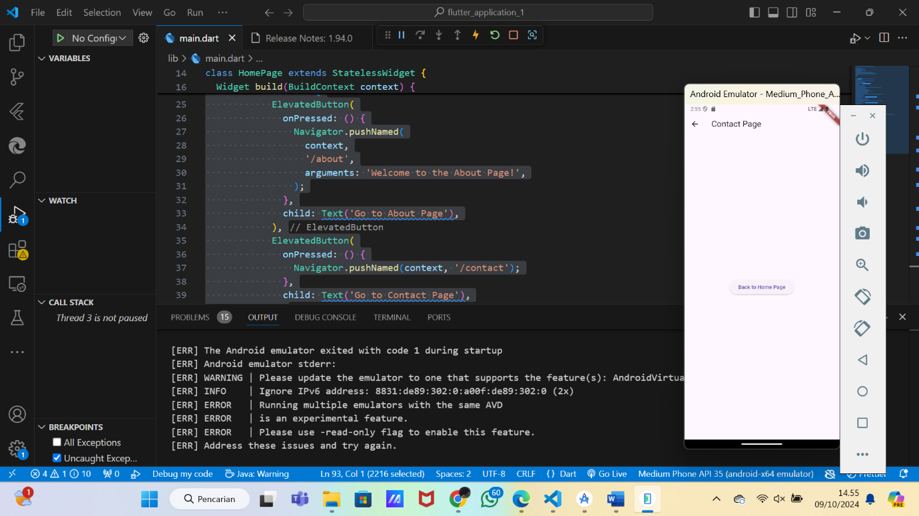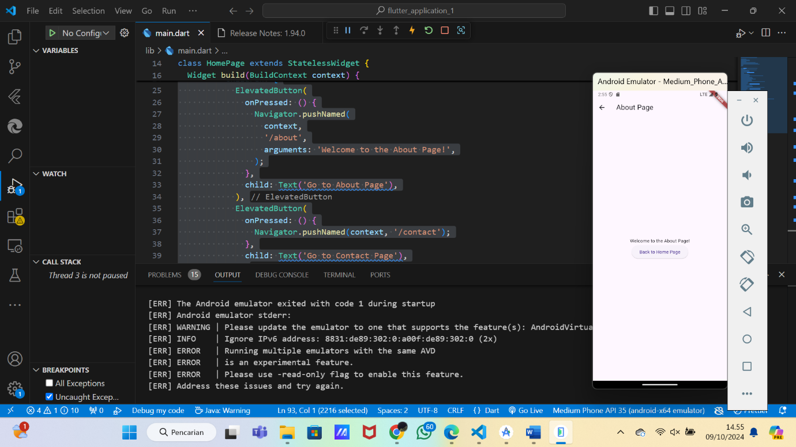

**3. Buat navigasi dinamis dengan MaterialPageRoute dan coba buat halaman baru secara dinamis berdasarkan input pengguna (misalnya, halaman dengan judul yang diinput oleh pengguna).**

import 'package:flutter/material.dart';

void main() {

runApp(MaterialApp(

initialRoute: '/',

routes: {

'/': (context) => HomePage(),

'/about': (context) => AboutPage(),

'/contact': (context) => ContactPage(),

},

));

}

class HomePage extends StatelessWidget {

final TextEditingController _controller = TextEditingController();

@override

Widget build(BuildContext context) {

return Scaffold(

appBar: AppBar(

title: Text('Home Page'),

),

body: Center(

child: Column(

mainAxisAlignment: MainAxisAlignment.center,

children: [

ElevatedButton(

onPressed: () {

Navigator.pushNamed(

context,

'/about',

arguments: 'Welcome to the About Page!',

);

},

child: Text('Go to About Page'),

),

ElevatedButton(

onPressed: () {

Navigator.pushNamed(context, '/contact');

},

child: Text('Go to Contact Page'),

),

SizedBox(height: 20),

TextField(

controller: _controller,

decoration: InputDecoration(hintText: 'Enter page title'),

),

ElevatedButton(

onPressed: () {

String title = _controller.text;

if (title.isNotEmpty) {

Navigator.push(

context,

MaterialPageRoute(

builder: (context) => DynamicPage(title: title),

),

);

}

},

child: Text('Create Dynamic Page'),

),

],

),

),

);

}

}

class AboutPage extends StatelessWidget {

@override

Widget build(BuildContext context) {

final String message = ModalRoute.of(context)!.settings.arguments as String;

return Scaffold(

appBar: AppBar(

title: Text('About Page'),

),

body: Center(

child: Column(

mainAxisAlignment: MainAxisAlignment.center,

children: [

Text(message),

ElevatedButton(

onPressed: () {

Navigator.pop(context);

},

child: Text('Back to Home Page'),

),

],

),

),

);

}

}

class ContactPage extends StatelessWidget {

@override

Widget build(BuildContext context) {

return Scaffold(

appBar: AppBar(

title: Text('Contact Page'),

),

body: Center(

child: ElevatedButton(

onPressed: () {

Navigator.pop(context);

},

child: Text('Back to Home Page'),

),

),

);

}

}

class DynamicPage extends StatelessWidget {

final String title;

DynamicPage({required this.title});

@override

Widget build(BuildContext context) {

return Scaffold(

appBar: AppBar(

title: Text(title),

),

body: Center(

child: ElevatedButton(

onPressed: () {

Navigator.pop(context);

},

child: Text('Back to Home Page'),

),

),

);

}

}

